**MIS Executive Committee Meeting**

Thursday, July 12th, 2012

8:30 to 9:30am (***via CCC Confer only***)

1. MIS – Spring 2012 Term-Based Files

|  |  |  |  |  |  |
| --- | --- | --- | --- | --- | --- |
| File | Name | # Records | | Total # Records | Notes/Comments |
| Crafton | Valley |
| SB | Student Basic | 8,023 | 15,659 | 23,682 |  |
| SX | Enrollment | 16,018 | 34,195 | 50,213 |  |
| CB | Course Basic | 664 | 978 | 1,642 |  |
| XB | Section | 557 | 1,175 | 1,732 |  |
| XF | Session | 750 | 1,876 | 2,626 |  |
| XE | Assignment | 787 | 2,104 | 2,891 |  |
| EB | Faculty Assignment |  |  |  | *Pending |
| SM | Matriculation | 5,785 | 12,690 | 18,475 |  |
| SD | Student Disability | 299 | 723 | 1,022 |  |
| SE | Student EOPS | 282 | 436 | 718 |  |
| SV | Student VTEA | 234 | 211 | 445 |  |
| SC | CalWorks Applicants | 24 | 215 | 239 |  |
| CW | CalWorks Jobs | 12 | 56 | 68 |  |
| SG | Special Groups | 54 | 114 | 168 | First-time submission |

• Submission ***target date*** is still July 18th, 2012

1. Last Day to Submit for Allocation Purposes*

•The first Monday in August (August 6th, 2012) is the last day to submit (or resubmit) Summer,

Fall and/or Spring term-end files for allocation purposes.

1. $0 BOGW Recipients

• Chancellor’s Office will pay particular attention to data element SF21 for the 0$ BOG Fee Waivers in the 2011-12 data submissions. Institutions must “affirmatively document those students who attended at least one meeting of a course prior to dropping all courses”.

***Question:***

How do we confirm/affirm/document that a BOGW student (who drops all of his courses) attended at least one meeting? Not a problem for Positive Attendance – Weekly/Daily?

***Response from Chancellor’s Office:***

Institutions may wish to follow the same procedures used for making this determination under Title IV requirements. Following is an excerpt from Volume 5, page 5-6 of the 2011-12 Handbook:

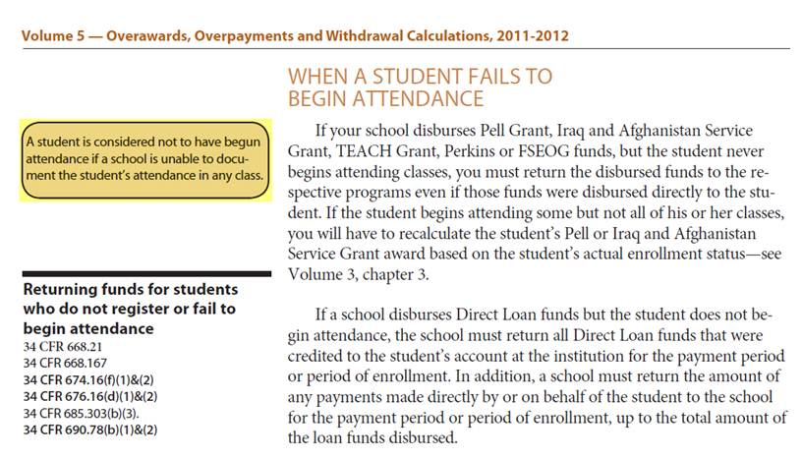

*A student is considered not to have begun attendance if a school is unable to document the student’s attendance in any class.*

IV. Gainful Employment – Update

The DOE is monitoring the Gainful Employment situation and will keep institutions posted, based upon a recent court decision that highlights the following:

•Institutions are **not required** to submit gainful employment reports for the 2011-2012 award year

•Major update to the **disclosure** requirement process is around the corner

GE Back-up Detail Reports have been placed in the institution-specified TG SAIG mailbox for

distribution and review to Instructional Departments. Currently in the process of accessing and

downloading these files.

V. Student Special Populations Group (SG) File

• SG file will be required as of Summer 2012 reporting

• SG file was included with Spring 2012 term data to evaluate processing (168 records)

* On March 29th, 2012 Requested list of students from specified populations by April 20th
  + Received only 1 list from Crafton EOPS Foster Youth
  + Military Status and Foster Youth system-derived from ISIR data.

VI. Miscellaneous

____________________________________________________________

____________________________________________________________

____________________________________________________________