MIS Executive Committee Meeting
Thursday, July 11th, 2013
10:30 to 11:30am
New Time – This meeting ONLY!!

I. MIS –Spring 2013 Reporting (in progress)

II. Status: SX02 error (meeting TBA by Joe Cabrales)
Grade of ‘W’ for course(s) dropped prior to census date

III. National Student Clearinghouse (NSC)
•Spring 2013 Degree file - due 07/16/2013

IV. New MIS Data File – Student Success ‘Draft’ (Mandatory, Summer 2014)
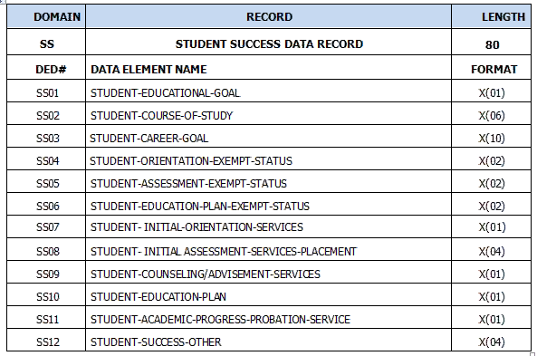

V. IPEDS Reporting (Discussion to be led by Keith Wurtz)
- IPEDS Reporting on Institutional Characteristics and 12-Month Enrollment
- IPEDS Reporting on Student Financial Aid
- IPEDS Reporting on Fall Enrollment
- IPEDS Reporting on Graduation Rates and 200% Graduation Rates
- IPEDS Reporting on Human Resources and Finance

