MIS Executive Committee Meeting
Thursday, October 17th, 2013
8:30 to 9:30am

Note: This is a Working Meeting dedicated to Student Success Beta Testing REVIEW and SETUP

- Review Translation Table(s) – Determine new codes to identify Student Success (SS) data elements.
CAST.SS.CONTACT using CONTACT.TYPE
CAST.SS.ACTIVITY using ACTIVITY.TYPE
CAST.SS.TEST using STNC.CATEGORY

- Review & Determine Parameter setup for each College (SSPD)
  - Rules for Exemption of
    - Orientation (SS03)
    - Assessment (SS04)
    - Ed Plan (SS05)
  - Rules for Services Provided
    - Orientation (SS06)
    - Counseling (SS08)
    - Ed Plan (SS09)
    - Academic Probation (SS10)
  - Comprehensive Ed Plan # of Terms – Determine “Greater than or equal to”

- If ALL Students Directed to Services, Orientation, Assessment, Ed Plan Exemption rules not necessary.
Interpretation per SUMMIT attendees is . . . if Associate Degree or Higher, student should be coded as Exempt from Orientation and Assessment. What is SBCCD’s position?

- Student Self-Service Planning Module – Without a purchased license agreement, unable to utilize the CCPI Course Planning Info screen. What is SBCCD’s position?

- Identify, compare, and resolve existing SM output to new SS output for several test students.

- Impact to SARS import process.
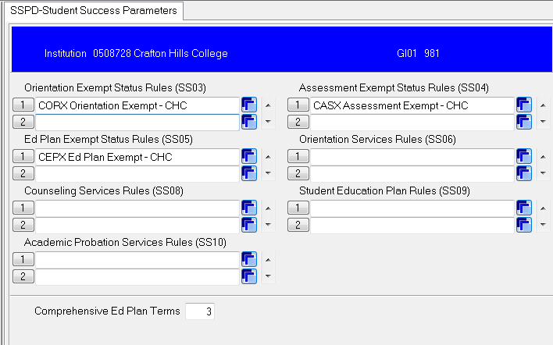

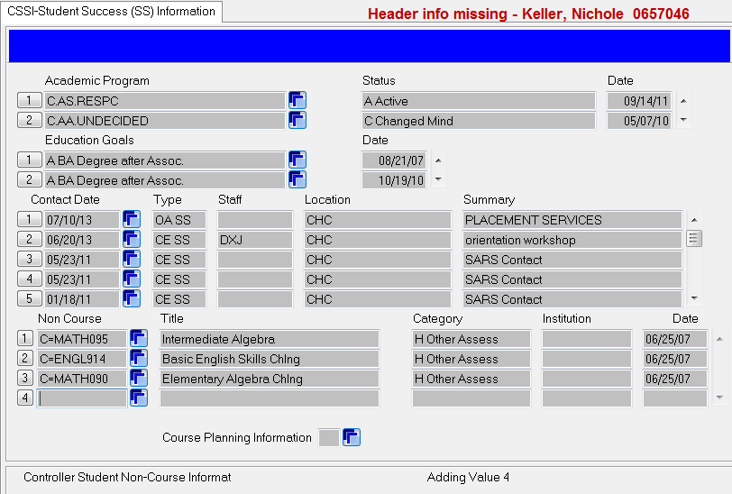
Additional information: field has been added to DETAIL to PERC, SACS, & STAT
Must have license for Student Self Service Course Planning Module
SS06
SS08
SS09
SS10
(CAST.SS.CONTACT)
(CAST.SS.ACTIVITY)
(CAST.SS.TEST)
SS07
Note: Additional function has been added to ‘Detail’ to PERC, SACS, and STAT screens from Additional Information

SBCCD does not currently have the Course Planning Module, so CCPI screen is currently NOT available.
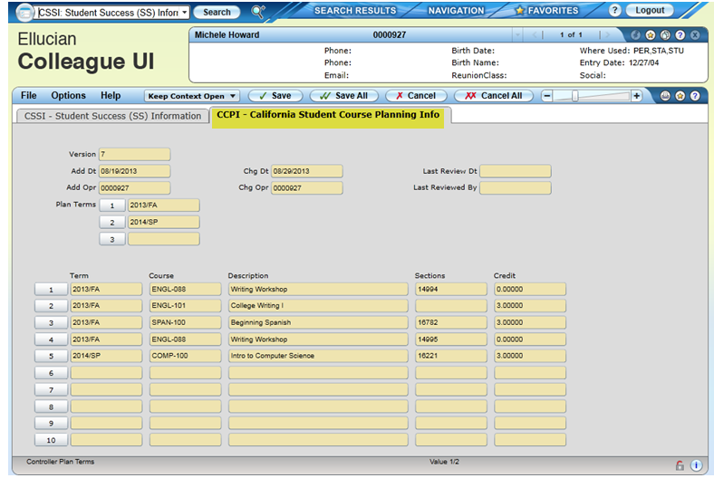

SAMPLE rule for Orientation EXEMPTION

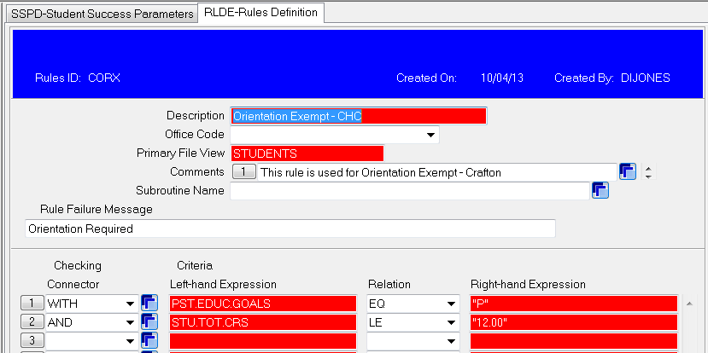

SAMPLE Translation Table Setup for CAST.SS.CONTACT

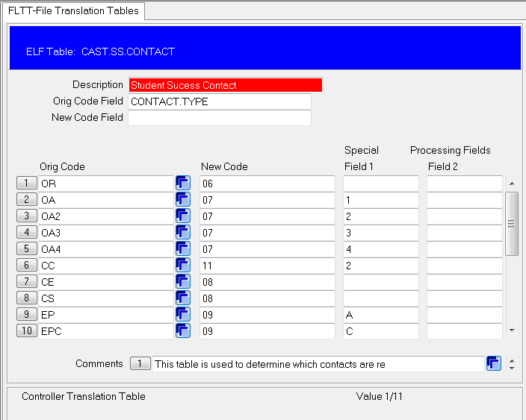

SAMPLE Translation Table Setup for CAST.SS.ACTIVITY

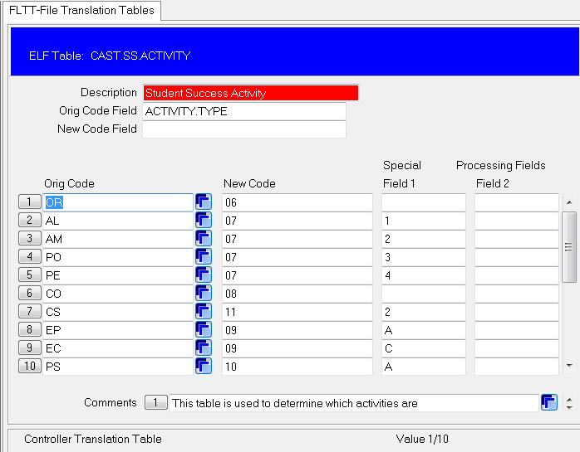

SAMPLE Translation Table Setup for CAST.SS.TEST

