MIS Executive Committee Meeting
Thursday, October 31st, 2013
8:30 to 9:30am

Note: This is a Working Session dedicated to Student Success Beta Testing REVIEW and SETUP

- Discuss New Translation Tables and Max Code Size
CAST.SS.CONTACT using CONTACT.TYPE
CAST.SS.ACTIVITY using ACTIVITY.TYPE (increase Max Size to 3)
CAST.SS.TEST using STNC.CATEGORY

- Discuss Parameter setup for each College (SSPD)
  - Rules for Exemption
CHC – If Associate Degree or Higher, exempt from Assessment & Orientation
SBVC – If Associate Degree or Higher, exempt from Orientation & Assessment

  - Rules for Services Provided
No rule necessary if contact type specified on CAST.SS.CONTACT translate table.

  - Comprehensive Ed Plan # of Terms = 3

- Student Self-Service Planning Module – Where are we in regards to funding/purchase?

- Discuss Contact Codes and their translation to Colleague MIS codes from:
  - SARS
  - Online Orientation (CHC)
  - Online Orientation (SBVC)

Sample ‘Test’ Result
Header Info – Issue
Student ID# 1303098
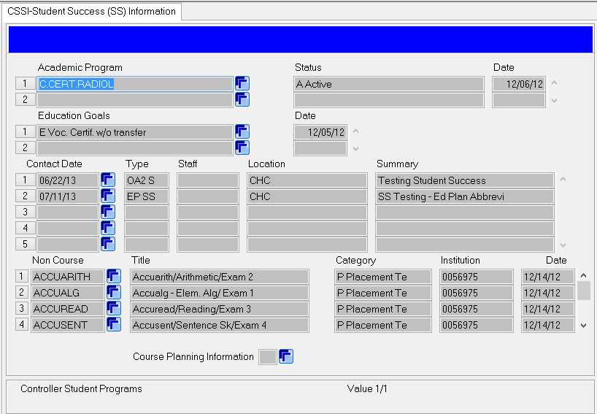

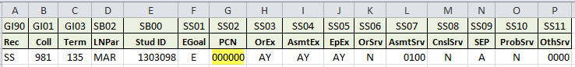
PCN s/b 04838 for C.CERT.RADIOL

