MIS Executive Committee Meeting
Thursday, February 6th, 2014
8:30 to 9:30am

I. MIS – Fall 2013 Reporting - COMPLETED
SX02 – Grade of ‘W’ assigned for course(s) dropped prior to census date.

II. Student Success (SS)
  - New BETA release expected this Friday, February 7th, 2014

  - Changes to:
    - SARS import to Colleague translation codes
    - Crafton Online Orientation (Cynosure) Import to Colleague
Create Contact records with contact type of “ORI”
Use actual ‘Date taken’
Update PERC holds
    - Valley Online Orientation (Comevo) Import to Colleague
Create Contact records with contact type of “ORI”
Continue to use ‘Date taken’ as indicated from Comevo
Update PERC holds

III. Student Planning – licensing obtained (CCPI)
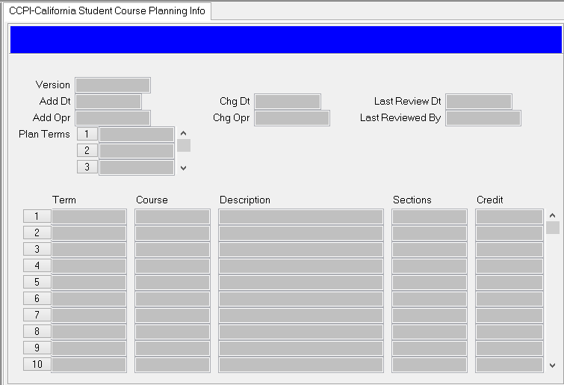

IV. Upcoming: NSC Degrees Fall 2013 – Due February 18th, 2014

V. Miscellaneous

