Per Myrna Huffman @ State Chancellor’s Office MIS Unit:
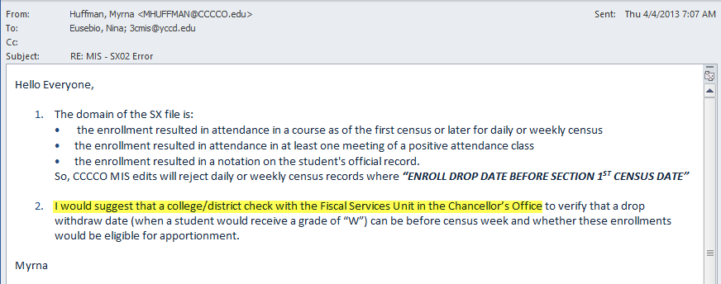

Per Elias Regalado @ State Chancellor’s Office Fiscal Services Unit:
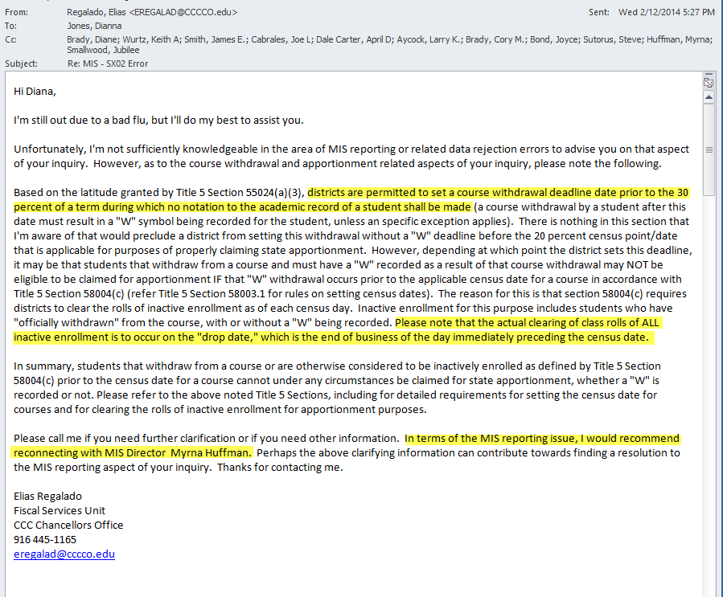
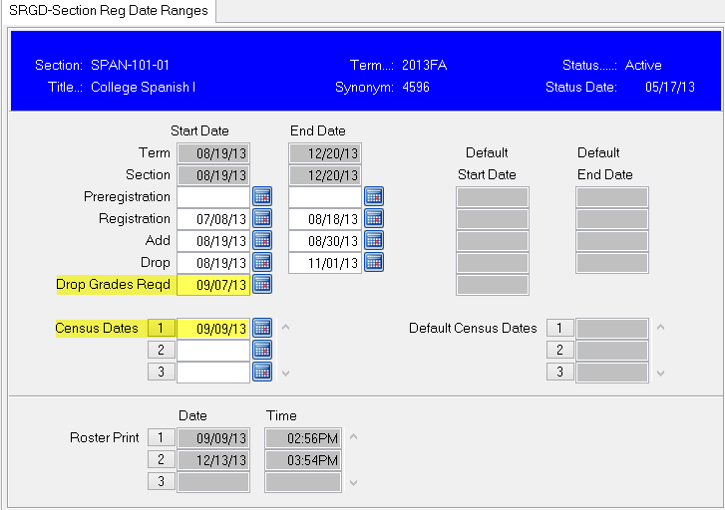
CHC had 27 SBVC had 46

