MIS Executive Committee Meeting
Thursday, April 20th, 2017

8:30 to 9:30am

- MIS – Spring 2017 Term
- EB/EJ staff data file created/sent to payroll.
- SG special populations groups – received MCHS (still need Puente & Tumaini)
- Missing CB00#s per XMDR

- Gainful Employment – new Disclosure Templates

Disclosure Templates - Status
https://ope.ed.gov/GainfulEmployment/

- Clearinghouse – Overdue Degree verifications
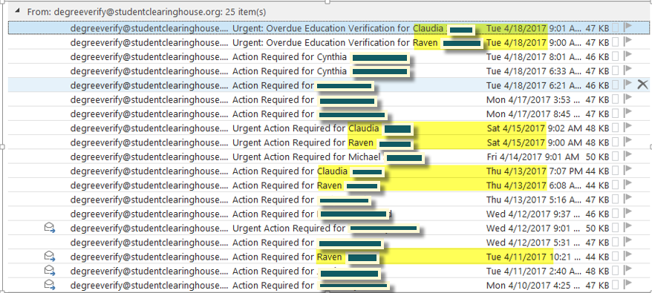

- Miscellaneous

