MIS Executive Committee Meeting
Thursday, April 19th, 2018

8:30am to 9:30am

- Valley: Course Types> ‘In Service’ value listed on the Course Types on SECT screen in Colleague.
  - Course Type INSER designation/code is on the valcode table, however, has never been used on any courses.
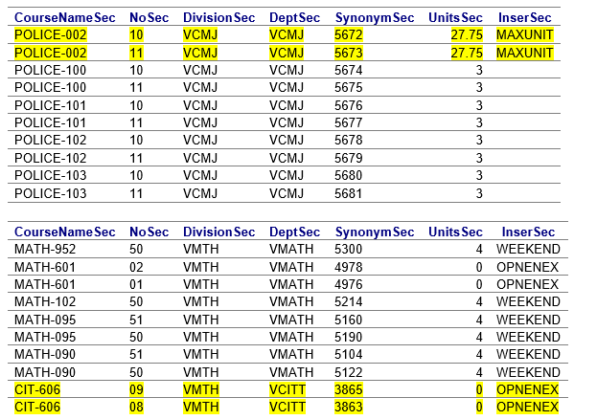

- MIS – Spring 2018 Term Processing Status
  - Instruction: All Spring 2018 enrolled courses have CB00#s entered in Colleague.

  - Payroll: The Spring 2018 Staff Data Download will be sent on April 23, 2018 to payroll for EB/EJ file processing.
    - Reminder: EB/EJ files to be returned to TESS by Friday June 1, 2018.

  - Special Groups: Student lists due to TESS by 05/25/2018
    - MCHS
    - Puente - Received 02/22/2018
    - Umoja (Tumaini) – Can utilize newly implemented flag to identify students or can submit student list.
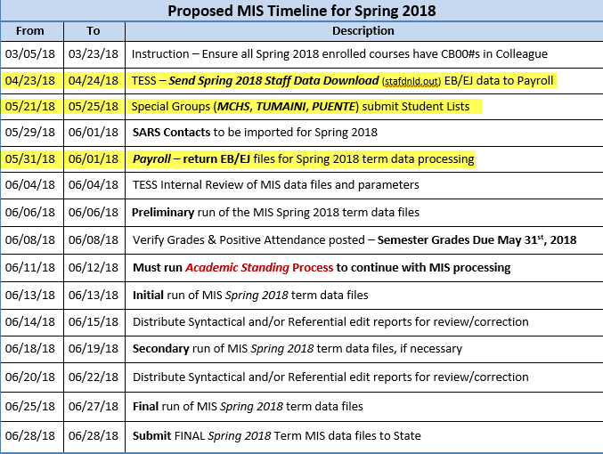

- MIS – Data Element changes effective Summer 2018
  - CCCCO notified Colleges/Districts of changes critical to MIS data collection and processing that will be implemented beginning Summer 2018.
  - Ellucian is still working on a patch to accommodate these upcoming changes within Colleague. Set to be released June 2018.

Student Basic Data Reporting
  - Amended: SB23 – Apprenticeship Status
    - Added Code: “2” to identify students who are participating in an approved pre-apprenticeship program.
      - Both Colleges’ Instruction Offices confirmed that at this time there are no pre-apprenticeships programs offered.

  - New: SB34 – CCC ID
    - New data element that contains the California Community College ID (CCCID) that is assigned during account create in OpenCCC.

  - New: SB35 – SS ID
    - New data element that contains the California Department of Education (CDE) California Longitudinal Pupil Achievement Data System (CALPADS) Statewide Student ID (SSID) that is assigned for the student while attending a public California K-12 school.

  - New: SB36 – Transgender status
    - New data element that indicates the student’s self-declared transgender status.

  - New: SB37 – Sexual Orientation status
    - New data element that indicates the student’s self-declared sexual orientation.

Student CalWORKs Data Reporting
  - New: SC18 – Eligibility Time Limit Status
    - New data element that indicates whether the student is within two years of exhausting CalWORKs program eligibility during the reporting term.

Special Populations Data Reporting
  - Amended: SG10 – CAA Status
    - Added Code: “2” to identify students who are participating in an Integrated Education and Training (IET) program that meets federal standards.
      - Both Colleges’ Instruction offices confirmed that at this time there are no IET programs offered.

  - New: SG14 – Economically Disadvantaged Status
    - New data element to identify students’ economically disadvantaged status.

- New: SG15 – Ex Offender Status
    - New data element that indicates whether the student is identified as having been subject to any stage of the criminal justice process at the point of enrolling in community college.
Special Populations Data Reporting (continued)
  - New: SG16 – Homeless Status
    - New data element that indicates whether the student is identified as homeless as defined by the Workforce Innovation and Opportunity Act.

  - New: SG17 – Long Term Unemployment Status
    - New data element that indicates whether the student is identified as being unemployed for 27 consecutive weeks or longer at the point they enrolled in community college.

  - New: SG18 – Cultural Barrier Status
    - New data element that indicates whether the student is self-identified as possessing attitudes, beliefs, customs, or practices that influence a way of thinking, acting, or working that may serve as a hindrance to employment at the point they enrolled in community college.

  - New: SG19 – Seasonal Farm Work Status
    - New data element that indicates whether the student was a seasonal farm worker at the point they enrolled in community college.

  - New: SG20 – Literacy Status
    - New data element that indicates whether the student had a low level of literacy at the point they enrolled in community college.

  - New: SG21 – Work Based Learning Status
    - New data element that indicates whether the student participated in specific types of work-based learning during the reporting term.

Student Financial Aid Reporting
  - Amended: SF21 – Student Aid Award Type
    - Added new award codes:
      - GH – Completion Grant (CCCG)
      - GI – Cal Grant A
      - GJ – Dreamer Grant
      - GQ – Equity Grant
      - GR – SSSP Grant

Student Assessment Data Reporting
  - New: SA07 – Student Educational Function Level
    - New data element that indicates the educational functioning level of the student as assessed using federally approved instruments.

- Miscellaneous
  - Next MIS Executive Meeting is Thursday May 3, 2018.

