MIS Executive Committee Meeting
Thursday May 31, 2018

8:30am to 9:30am

- Crafton: Adding “DE71L” as a method within Colleague
  - Prior DAWG agenda item: Reach a consistency on its use across both campuses.
  - Both Colleges must agree on this Instruction method to be created (referencing DAWG meeting)

(Snapshot from CCCCO Data Element Dictionary – XF01 Session Instruction Method)
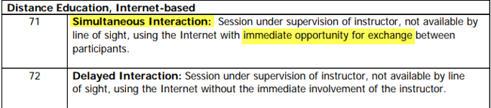

- MIS – Spring 2018 Term Processing Status
    - Payroll returned the EB/EJ file on May 25, 2018
  - MIS Files still to be created:
    - Student Success (SS) – Pending SARS contacts
    - Student Enrollment (SX) – Pending Grades & Academic Standing
    - Student Basic (SB) – Pending all MIS file to be created
    - College Calendar (190) – Holidays being rejected. Call to CCCO.

- MIS – Spring 2018 Deadline Reminders
  - DUE Friday June 1, 2018
    - SARS Contacts to be imported
    - DSPS & EOPS Data Reports counts to be confirmed

- MIS – Data Element changes effective Summer 2018
  - Initial conversation to establish process of data collection for new data elements:
    - SB36 – Transgender status
    - SB37 – Sexual Orientation status

- Miscellaneous

