The September 20, 2018 MIS meeting began at 8:35 a.m. at the District Annex Conference Room 3 with the following discussions and individuals in attendance (* = via ZOOM):

Present: * Corrina Baber, *Yancie Carter, *Artour Aslanian, *Kristina Heilgeist, *Miriam Saadah,
*Dianna Jones, *James Smith

- MIS – Summer 2018 reporting – Completed

Summer 2018 MIS Reporting Issues/Anomalies resulting in Edit Errors

File | Name | Edit Error Description
SB | Student Basic | Education Status and Enrollment Status Do not Agree
CB | Course Basic | CB11 Noncredit Courses value invalid (AERO-653L/654L, ENGL-615)
SC | CalWORKs | NEW field (SC18) needs to be updated
XE | Assignment | Cancelled Section, but faculty assigned on (SECT/FASC)
SX | Enrollment | SX04 Cancelled Section/Multiple duplicate statuses
SS | Student Success | Undecided/Undeclared Major & Comprehensive Ed Plan

Although we were late this cycle, all files were submitted. There were a few issues and we wanted to report out to the MIS Committee, such as education and enrollment status did not agree; SBVC has students identified as high school although they may have graduated in May or June, registered for Summer or Fall, and not updated. Kristina Heilgeist will reach out to Floyd Simpson at CHC and Yancie Carter will reach out to April Dale-Carter, SBVC. Also, there were many CB11s in the Course file that were inaccurately coded.

In CalWORKs, had to do testing, move into non-production environments, then moved it to LIVE, now in LIVE environment. Notices have been sent to both college departments to update fields (currently submitted as unknown.) They have about a week or so to do that in Annual.

With the XE file, we had sections which had been cancelled, however there were faculty still attached to the section. Is it protocol to remove faculty from a cancelled section? When faculty are left on the section, it creates an XE assignment. It seems we need to follow up with the workflow process with both campuses, as we need to understand, confirm if this is an oversight. Can we modify workflow?

The SX file had one error in particular which was multiple statuses. The section was added, students added, section cancelled, then students were added again. Will be discussed at length with the campus.

In the SS Undecided/Undeclared Major and Comprehensive Ed Plan, update the Comprehensive Ed Plan to an Abbreviated Ed Plan, which is less money, however it is more money than deleting from the file. Until that gets resolved on the student level, there is nothing we can do except change the comprehensive to an Abbreviated Ed Plan.

- MIS – Annual 2018 – Status
Student Program (SP) Awards – Past Due as of September 15th, 2018
This file is late, however we will need to submit due to IPEDS utilizing this data. Will be in touch with the Evaluators who verify the counts.
Student Financial Aid (SF/FA) – Due October 1st, 2018
Student Assessment (SA) – Due October 31st, 2018

- Existing MIS-related projects
- Implementation of the new Student Success Completion Grant (SSCG)
For the SSCG, we have developed a set-up and test plan, involved Financial Aid, Fiscal Services and the IT Department by setting up the columns, and sub-routines that we need to determine how the grant is awarded and transmitted. We expect to hear no later than the 24th so we may transfer to test environment.
- Review and setup of the new Student Assessment data element, SA07
SA07 – New Student-Educational-Function-Level classifies student based on range of scores tied to each level from Beginning to Advanced levels of basic education or ESL.

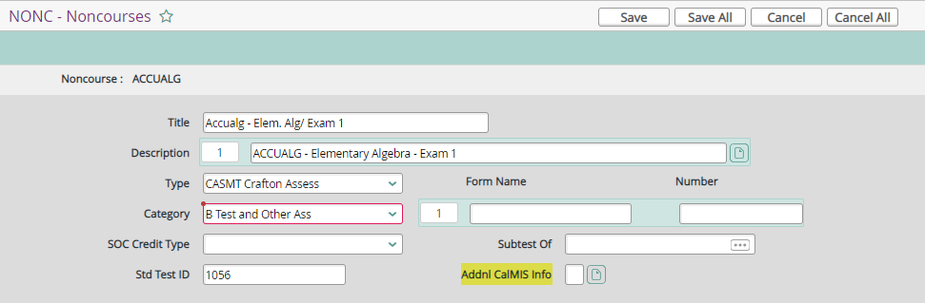

Based on the test the student takes, the score that they get is supposed to be coded with one of these levels. Involves Yancie Carter, Counseling area for the assessment. Requires getting together and deciding (Counselors and Researchers), what student ed function level THIS score falls into. The assessment we are recording on is for LAST YEAR (July 2017 through June 2018). More information forthcoming. Will be set up for next reporting period (July 2018-June 2019). Yancie will keep on the radar, will inform all of this upcoming.

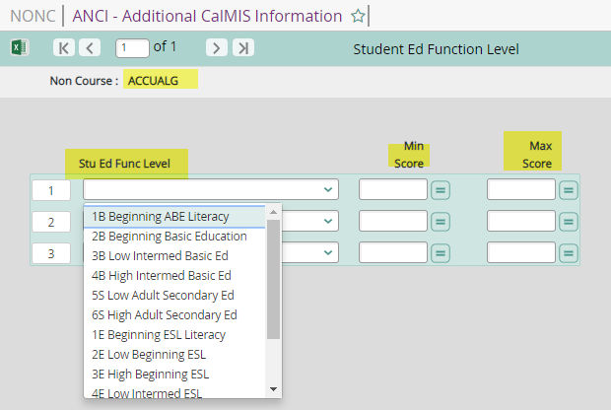

- Miscellaneous
Clearinghouse “Urgent: Overdue Education Verification for …”
Several Clearinghouse emails are coming in as “URGENT, verification is overdue.” These notices are generally for students who have been offered a job and remain pending until verification, sometimes for 7-10 days. These verifications are done in the Admissions and Records Office. Yancie Carter mentioned he will pass this message along to April Dale-Carter, Director of Admissions and Records at SBVC.

Gainful Employment
Is Gainful Employment reporting going away? Typically due to in October.

Next MIS Executive Committee Meeting
Thursday, October 4, 2018

